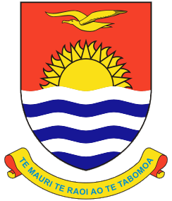 | KIRIBATI SHIP REGISTRY
 | Declaration of Management Company

The ISM Code requires that a Company be declared to the Administration. In accordance with Section 1.1.2 of IMO Resolution A741(18) of the ISM Code, “Company means the Owners of a ship or any organization or person such as the Manager, or the Bareboat Charterers, who has assumed the responsibility for the operation of the ship from the ship Owners and who on assuming such responsibility has agreed to take over all the duties and responsibility imposed by the Code”. The undersigned affirms that:
Name Of Company |  |  | Company IMO No.
Telephone | Fax | Email
Full Address
is the Registered Owner of the following Kiribati registered vessel(s):*

Name of Vessel | Official Number | Call Sign | IMO Number

In accordance with Section 3.1 of the Assembly Resolution 741 (18), if the entity that is responsible for the operation of the vessel is other than the above stated Owners, the Owners must report the full name and details of such entity to the Administration. If such is the case here, the undersigned affirms that:
Name Of Company |  |  | Company IMO No.
Telephone | Fax | Email
Full Address
is the “Company” responsible for all the requirements imposed by the Code for the Kiribati registered vessel(s) listed above.

The undersigned affirms that has been appointed the Recognized Organization (RO) for the purpose of the issuance of a Document of Compliance.

The undersigned further understands that any change in “Company” or RO must be made in writing by email to the Administration. Any change will be acknowledged within 24 hours of being received.

Name & Title (on behalf of Registered Owner) | Signature | Date

